**SQL PROJECT**

Name:Sujal Shetty

ROLL.NO:31

Subject:Pl/SQL

Topic:Hotel database

# Database name-Vihangs_inn

Entities:

1.Employee:

Attributes:

* E_id*
* E_name
* E_dob
* Date_of_joining
* Gender
* Mobile_no
* Shifts
* Salary
* room_id#
* d_id#

2.Bill

Attributes:

* Bill_id*
* Amount
* Date
* Mode

3.Customers

Attributes:

* Cust_id*
* Cust_name
* dob
* Gender
* Address
* Date_of_checkin
* Date_of_checkout
* room_id#
* Bill_id#

4.Department

Attributes:

* d_id*
* d_name
* Phone_no
* Floor
* Open_hrs
* Close_hrs

5.Room

Attributes:

* room_id*
* Floor
* Type
* Charges
* Availability
* d_id#

**ERD DIAGRAM:**

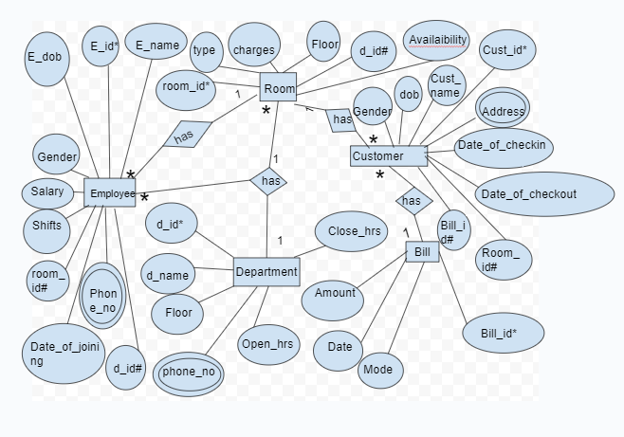

1.

Create database Vihangs_inn;



2.

Use Vihangs_inn;



3.

Create table Department(

d_id int not null,

d_name varchar(30) not null,

Phone_no bigint not null,

Floor varchar(20) not null,

Open_hrs varchar(30) not null,

Close_hrs varchar(30) not null,

check(Phone_no<=9999999999 and Phone_no>=100000000),

Primary key(d_id)

);

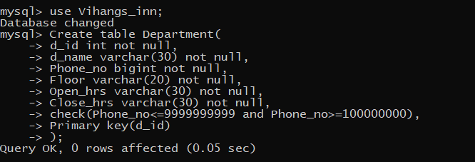

4.

Create table Room(

room_id int not null,

Floor varchar(20) not null,

Type varchar(40) not null,

Charges int not null,

Availability varchar(30) not null,

d_id int not null,

Primary key (room_id),

Foreign key(d_id) references Department(d_id)

);

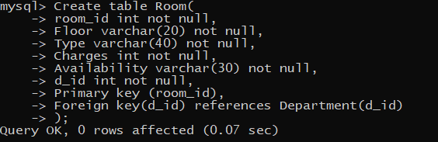

5.

Create table Bill(

Bill_id int not null,

Amount int not null,

Date date,

Mode varchar(30) not null,

Primary key(Bill_id)

);

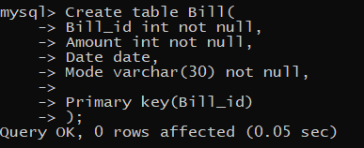

6.

Create table Customers(

Cust_id int not null,

Cust_name varchar(50),

dob date,

Gender varchar(8) not null,

Address varchar(50) not null,

Date_of_checkin date,

Date_of_checkout date,

room_id int not null,

Bill_id int not null,

Primary key(Cust_id),

Foreign key(room_id) references Room(room_id),

Foreign key(Bill_id) references Bill(Bill_id)

);

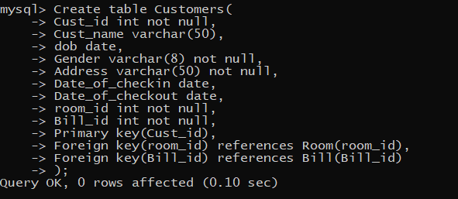

7.

create table Employee(

E_id int not null,

E_name varchar(50) not null,

E_dob date,

Date_of_joining date,

Gender varchar(8) not null,

Mobile_no bigint not null,

Shifts varchar(30) not null,

Salary int not null,

room_id int ,

d_id int not null,

check(Mobile_no<=9999999999 and Mobile_no>=1000000000),

Primary key(E_id),

Foreign key(room_id) references Room(room_id),

Foreign Key(d_id) references Department(d_id)

);

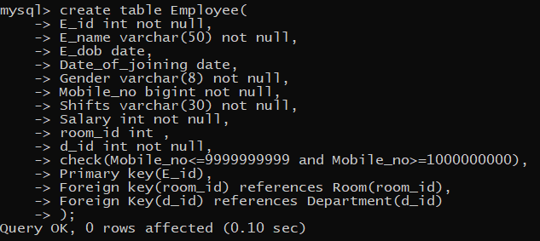

8.

INSERT INTO Department(d_id, d_name, Phone_no, Floor, Open_hrs, Close_hrs) VALUES

(1, 'Reception', 9876543210, 'Ground floor', '6am', '11pm');

INSERT INTO Department(d_id, d_name, Phone_no, Floor, Open_hrs, Close_hrs) VALUES

(2, 'Housekeeping', 9876543211, '1st floor', '8am', '8pm');

INSERT INTO Department(d_id, d_name, Phone_no, Floor, Open_hrs, Close_hrs) VALUES

(3, 'Catering', 9876543212, '2nd floor', '7am', '10pm');

INSERT INTO Department(d_id, d_name, Phone_no, Floor, Open_hrs, Close_hrs) VALUES

(4, 'Maintenance', 9876543213, '3rd floor', '9am', '5pm');

INSERT INTO Department(d_id, d_name, Phone_no, Floor, Open_hrs, Close_hrs) VALUES

(5, 'Security', 9876543214, 'Ground floor', '24hrs', '24hrs');

INSERT INTO Department(d_id, d_name, Phone_no, Floor, Open_hrs, Close_hrs) VALUES

(6, 'Laundry', 9876543215, 'Basement', '10am', '7pm');

INSERT INTO Department(d_id, d_name, Phone_no, Floor, Open_hrs, Close_hrs) VALUES

(7, 'Spa', 9876543216, '2nd floor', '10am', '8pm');

INSERT INTO Department(d_id, d_name, Phone_no, Floor, Open_hrs, Close_hrs) VALUES

(8, 'Gym', 9876543217, '3rd floor', '6am', '10pm');

INSERT INTO Department(d_id, d_name, Phone_no, Floor, Open_hrs, Close_hrs) VALUES

(9, 'Pool', 9876543218, 'Ground floor', '7am', '9pm');

INSERT INTO Department(d_id, d_name, Phone_no, Floor, Open_hrs, Close_hrs) VALUES

(10, 'Parking', 9876543219, 'Basement', '24hrs', '24hrs');

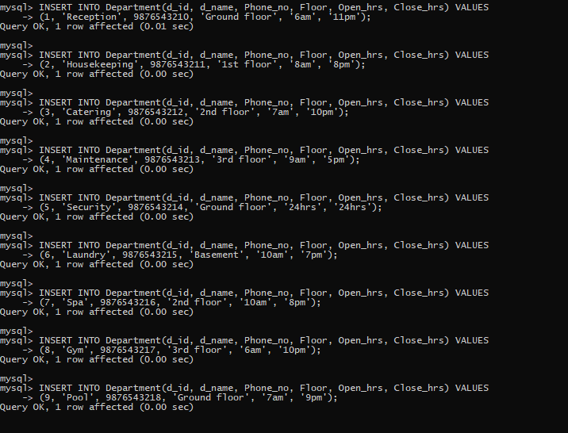

9.

INSERT INTO Room(room_id, Floor, Type, Charges, Availability, d_id) VALUES

(1, '1st floor', 'Studio', 100, 'Vacant', 1);

INSERT INTO Room(room_id, Floor, Type, Charges, Availability, d_id) VALUES

(2, '2nd floor', 'Family room', 200, 'Reserved', 2);

INSERT INTO Room(room_id, Floor, Type, Charges, Availability, d_id) VALUES

(3, '3rd floor', 'Executive suite', 300, 'Booked', 3);

INSERT INTO Room(room_id, Floor, Type, Charges, Availability, d_id) VALUES

(4, '1st floor', 'Presidential suite', 400, 'Vacant', 4);

INSERT INTO Room(room_id, Floor, Type, Charges, Availability, d_id) VALUES

(5, '2nd floor', 'Studio', 150, 'Reserved', 5);

INSERT INTO Room(room_id, Floor, Type, Charges, Availability, d_id) VALUES

(6, 'Ground floor', 'Executive suite', 250, 'Booked', 6);

INSERT INTO Room(room_id, Floor, Type, Charges, Availability, d_id) VALUES

(7, '3rd floor', 'Presidential suite', 350, 'Vacant', 7);

INSERT INTO Room(room_id, Floor, Type, Charges, Availability, d_id) VALUES

(8, '1st floor', 'Studio', 120, 'Reserved', 8);

INSERT INTO Room(room_id, Floor, Type, Charges, Availability, d_id) VALUES

(9, '2nd floor', 'Family room', 220, 'Booked', 9);

INSERT INTO Room(room_id, Floor, Type, Charges, Availability, d_id) VALUES

(10, '3rd floor', 'Executive suite', 320, 'Vacant', 10);

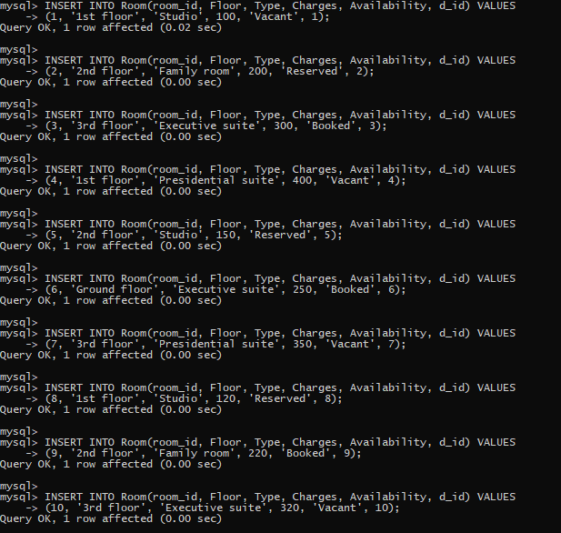

10.

INSERT INTO Bill(Bill_id, Amount, Date, Mode) VALUES

(1, 150, '2023-10-01', 'Cash');

INSERT INTO Bill(Bill_id, Amount, Date, Mode) VALUES

(2, 250, '2023-10-02', 'Online payment');

INSERT INTO Bill(Bill_id, Amount, Date, Mode) VALUES

(3, 350, '2023-10-03', 'Credit Card');

INSERT INTO Bill(Bill_id, Amount, Date, Mode) VALUES

(4, 450, '2023-10-04', 'Debit Card');

INSERT INTO Bill(Bill_id, Amount, Date, Mode) VALUES

(5, 550, '2023-10-05', 'Cheque');

INSERT INTO Bill(Bill_id, Amount, Date, Mode) VALUES

(6, 150, '2023-10-06', 'Cash');

INSERT INTO Bill(Bill_id, Amount, Date, Mode) VALUES

(7, 250, '2023-10-07', 'Online payment');

INSERT INTO Bill(Bill_id, Amount, Date, Mode) VALUES

(8, 350, '2023-10-08', 'Credit Card');

INSERT INTO Bill(Bill_id, Amount, Date, Mode) VALUES

(9, 450, '2023-10-09', 'Debit Card');

INSERT INTO Bill(Bill_id, Amount, Date, Mode) VALUES

(10, 550, '2023-10-10', 'Cheque');

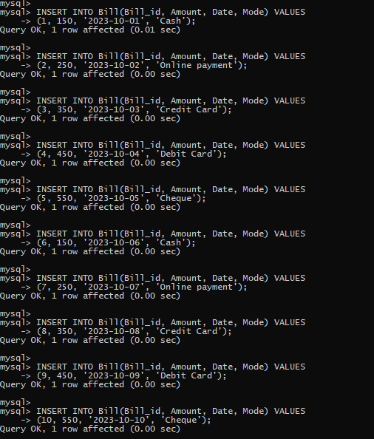

11.

INSERT INTO Customers(Cust_id, Cust_name, dob, Gender, Address, Date_of_checkin, Date_of_checkout, room_id, Bill_id) VALUES

(1, 'John Doe', '1990-01-01', 'Male', '123 Main St', '2023-10-01', '2023-10-05', 1, 1);

INSERT INTO Customers(Cust_id, Cust_name, dob, Gender, Address, Date_of_checkin, Date_of_checkout, room_id, Bill_id) VALUES

(2, 'Jane Smith', '1992-05-05', 'Female', '456 Elm St', '2023-10-02', '2023-10-06', 2, 2);

INSERT INTO Customers(Cust_id, Cust_name, dob, Gender, Address, Date_of_checkin, Date_of_checkout, room_id, Bill_id) VALUES

(3, 'Alice Brown', '1993-02-02', 'Female', '789 Maple St', '2023-10-03', '2023-10-07', 3, 3);

INSERT INTO Customers(Cust_id, Cust_name, dob, Gender, Address, Date_of_checkin, Date_of_checkout, room_id, Bill_id) VALUES

(4, 'Bob White', '1989-12-12', 'Male', '101 Pine St', '2023-10-04', '2023-10-08', 4, 4);

INSERT INTO Customers(Cust_id, Cust_name, dob, Gender, Address, Date_of_checkin, Date_of_checkout, room_id, Bill_id) VALUES

(5, 'Charlie Green', '1995-03-03', 'Male', '202 Oak St', '2023-10-05', '2023-10-09', 5, 5);

INSERT INTO Customers(Cust_id, Cust_name, dob, Gender, Address, Date_of_checkin, Date_of_checkout, room_id, Bill_id) VALUES

(6, 'Daisy Black', '1988-04-04', 'Female', '303 Birch St', '2023-10-06', '2023-10-10', 6, 6);

INSERT INTO Customers(Cust_id, Cust_name, dob, Gender, Address, Date_of_checkin, Date_of_checkout, room_id, Bill_id) VALUES

(7, 'Ella Grey', '1994-06-06', 'Female', '404 Cedar St', '2023-10-07', '2023-10-11', 7, 7);

INSERT INTO Customers(Cust_id, Cust_name, dob, Gender, Address, Date_of_checkin, Date_of_checkout, room_id, Bill_id) VALUES

(8, 'Frank Red', '1987-07-07', 'Male', '505 Dogwood St', '2023-10-08', '2023-10-12', 8, 8);

INSERT INTO Customers(Cust_id, Cust_name, dob, Gender, Address, Date_of_checkin, Date_of_checkout, room_id, Bill_id) VALUES

(9, 'Grace Blue', '1996-08-08', 'Female', '606 Fir St', '2023-10-09', '2023-10-13', 9, 9);

INSERT INTO Customers(Cust_id, Cust_name, dob, Gender, Address, Date_of_checkin, Date_of_checkout, room_id, Bill_id) VALUES

(10, 'Henry Yellow', '1986-09-09', 'Male', '707 Spruce St', '2023-10-10', '2023-10-14', 10, 10);

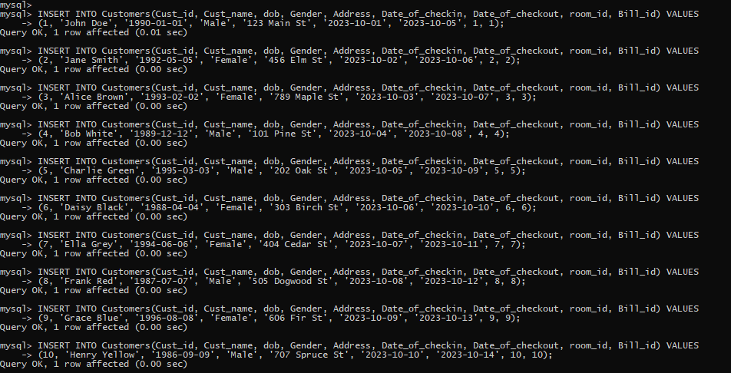

12.

INSERT INTO Employee(E_id, E_name, E_dob, Date_of_joining, Gender, Mobile_no, Shifts, Salary, room_id, d_id) VALUES

(1, 'Mike', '1985-01-15', '2019-01-01', 'Male', 9123456780, '8am-5pm', 1000, 1, 1);

INSERT INTO Employee(E_id, E_name, E_dob, Date_of_joining, Gender, Mobile_no, Shifts, Salary, room_id, d_id) VALUES

(2, 'Linda', '1987-02-20', '2020-02-02', 'Female', 9123456781, '9am-6pm', 1100, 2, 2);

INSERT INTO Employee(E_id, E_name, E_dob, Date_of_joining, Gender, Mobile_no, Shifts, Salary, room_id, d_id) VALUES

(3, 'Oscar', '1980-03-25', '2018-03-03', 'Male', 9123456782, '1pm-10pm', 1200, 3, 3);

INSERT INTO Employee(E_id, E_name, E_dob, Date_of_joining, Gender, Mobile_no, Shifts, Salary, room_id, d_id) VALUES

(4, 'Eva', '1982-04-30', '2017-04-04', 'Female', 9123456783, '7am-4pm', 1300, 4, 4);

INSERT INTO Employee(E_id, E_name, E_dob, Date_of_joining, Gender, Mobile_no, Shifts, Salary, room_id, d_id) VALUES

(5, 'Tom', '1983-05-05', '2016-05-05', 'Male', 9123456784, '10am-7pm', 1400, 5, 5);

INSERT INTO Employee(E_id, E_name, E_dob, Date_of_joining, Gender, Mobile_no, Shifts, Salary, room_id, d_id) VALUES

(6, 'Sophia', '1986-06-10', '2015-06-06', 'Female', 9123456785, '2pm-11pm', 1500, 6, 6);

INSERT INTO Employee(E_id, E_name, E_dob, Date_of_joining, Gender, Mobile_no, Shifts, Salary, room_id, d_id) VALUES

(7, 'Charlie', '1988-07-15', '2014-07-07', 'Male', 9123456786, '6am-3pm', 1600, 7, 7);

INSERT INTO Employee(E_id, E_name, E_dob, Date_of_joining, Gender, Mobile_no, Shifts, Salary, room_id, d_id) VALUES

(8, 'Olivia', '1981-08-20', '2013-08-08', 'Female', 9123456787, '3pm-12am', 1700, 8, 8);

INSERT INTO Employee(E_id, E_name, E_dob, Date_of_joining, Gender, Mobile_no, Shifts, Salary, room_id, d_id) VALUES

(9, 'David', '1984-09-25', '2012-09-09', 'Male', 9123456788, '9pm-6am', 1800, 9, 9);

INSERT INTO Employee(E_id, E_name, E_dob, Date_of_joining, Gender, Mobile_no, Shifts, Salary, room_id, d_id) VALUES

(10, 'Emma', '1989-10-30', '2011-10-10', 'Female', 9123456789, '11pm-8am', 1900, 10, 10);

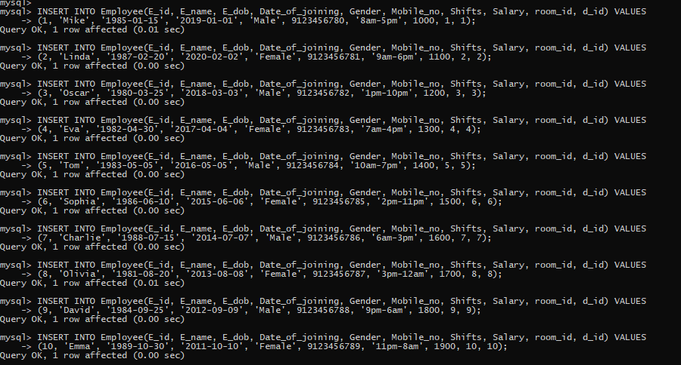

13.

Select* from Department;

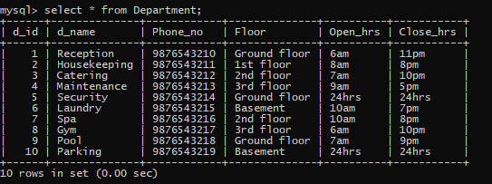

14.

Select * from Room;

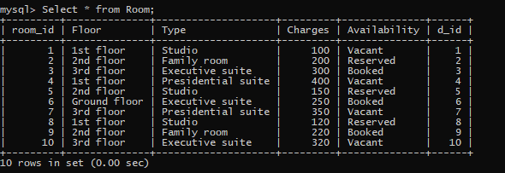

15.

Select * from Bill;

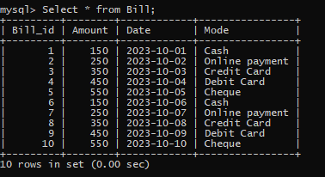

16.

Select * from Customers;

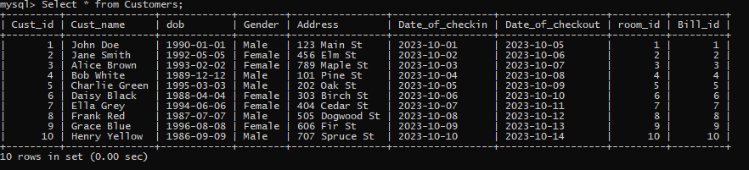

17.

Select * from Employee;

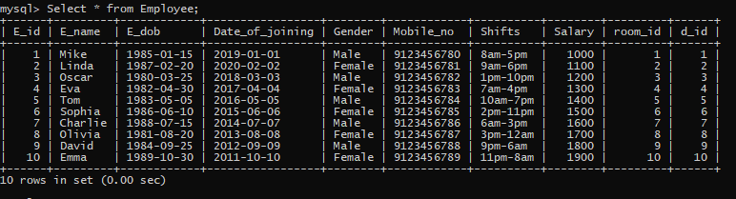

18.

select Avg(Salary) as "Average Salary of Employees" from Employee;

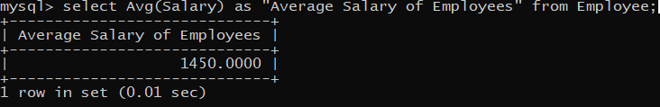

19.

select floor(DATEDIFF(CURDATE(),E_dob)/365) as "AGE" from Employee;

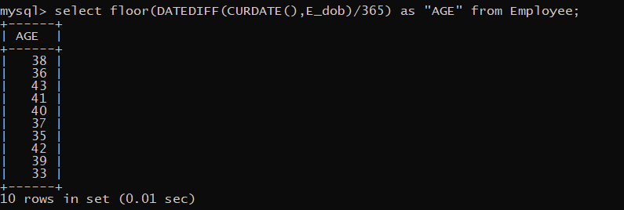

20.

select sum(Salary) from Employee;

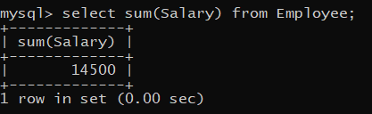

21.

select floor(DATEDIFF(CURDATE(),dob)/365) as "AGE" from Customers;

